Assistive Technology, Positive Deviance, and Human Centered Design
Defining the Problem Meeting Notes
Meagan Kendall

Assistive Technology, Positive Deviance, and Human Centered Design
Addressing Issues of Assistive Technology (AT) Access in the Paso del Norte Region Using Positive Deviance (PD) Inquiry and Human Centered Design (HCD)
September 30, 2016 Meeting Report
Location: University of Texas at El Paso, El Paso, Texas

September 30, 2016 Meeting Summary
Attendees:
Marcia Lopez | EPCC
Jan Lockhart | EPCC
Leonor Ibarra | UTEP Rehabilitation Counseling
Stanley Mubako | UTEP Geological Sciences
Meagan Kendall | UTEP Engineering Education and Leadership
Joey Acosta | Volar Center for Independent Living

Meeting Purpose: This meeting was convened to bring together community members and UTEP faculty interested in addressing Assistive Technology (AT) access issues in the Paso del Norte Region. Specifically, this group has interest in utilizing Positive Deviance (PD) Inquiry to address these issues. The group also sees value in applying the principles of Human Centered Design down the road to help design solutions to “the Assistive Technology problem” in our region. This is the third meeting of this group.

The first meeting included an introduction to AT, PD, and HCD, and an introduction to mapping. Materials from the first meeting, held on July 12, 2016, can be downloaded here: https://www.dropbox.com/sh/43cxfo4bqqtb1lv/AAC9AtZgkyn3UByebuUhUXDta?dl=0

The second meeting held on July 25, 2016 to continue the conversation initiated during the first meeting and to continue with the mapping workshop exercises. Dr. Stanley Mubako of The University of Texas at El Paso’s Geological Sciences Department, Center for Environmental Resource Management (CERM) led this part of the workshop. Materials from the mapping workshop can be found in the dropbox link above.

Following the mapping portion of the workshop, the second meeting focused on seeking answers to the following questions: “When you hear the phrase ‘Assistive Technology (AT) problem in our region’ what comes to mind?” “What is access?” “How do you define access?” “How would we measure these variables?” The notes from the meeting can be found at: https://www.dropbox.com/s/05oripvsyhacqwk/Assistive%20Technology%2C%20Positive%20Deviance%2C%20and%20Human%20Centered%20Design%20Meeting%20Report%208-31-16.docx?dl=0

This third meeting continued to build upon the results of the prior meetings with a focus on addressing the first D of PD: Define the Problem. The agenda for the meeting was therefore:
- Opening Circle to reintroduce ourselves
- Review brief handout and slides about the D’s of PD using the Vietnam story to refresh our memories
- Recap of the last meeting for those not in attendance
  - Reviewed the results obtained from the 1-2-4-All discussion for the prompt question: “When you hear the phrase ‘Assistive Technology (AT) problem in our region’ what comes to mind?”
- Open discussion about what was missing from the “Access to AT” issues graphic.
- Open discussion to narrow to top two issues worth focusing on.

Meeting Outcomes:
For agenda item 2, the following table was used to summarize the steps, D’s, of PD.
During agenda items 3, the meeting attendees were provided with a copy of the organized results from the Meeting 2 discussion about Access Issues. Multiple suggestions were made to build upon the initial graphic and are shown below in red.
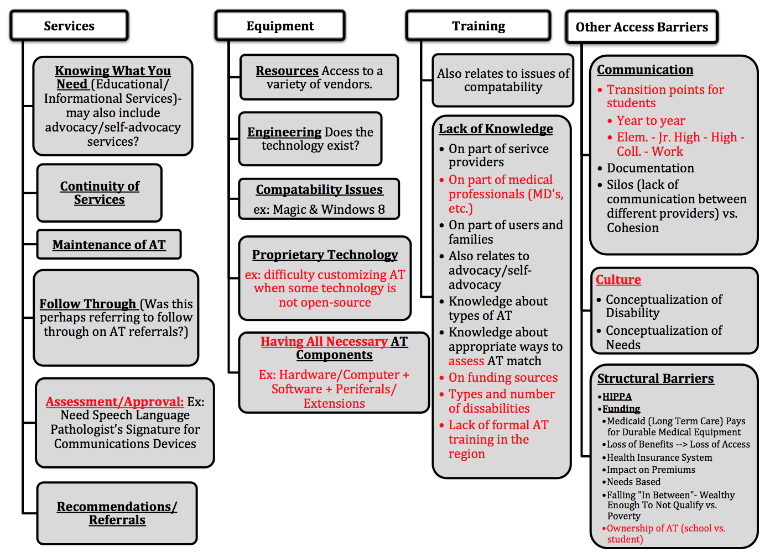
General discussion points brought up during the conversation about missing items (agenda item 4) were:
- We need to pay attention to what age group we’re focusing on. Adults, Children, even Veterans have different needs.
- For the most part, students in the local ISD’s are well cared for. However, TX has placed a cap on the % of students in a given school that can be classified as having a disability.
- We should keep in mind that some individuals may have comorbidities.
- The type of disability really impacts what AT is required and therefore could impact access as well.
Following the review and edits to the AT Access Issues graphic, the question was posed to the group (agenda item 5): “Which of these do you perceive is the greatest issue?”
The immediate response that several in the group brought up was funding. However, upon discussion and further reflection, the group established that the root issue to why there are funding issues is because we don’t have any data to help get funding. On top of that, training in what funding is available is also lacking. It was noted that funding is particularly problematic in a couple places: at transition points from HS to College and for those that make just enough money to no longer qualify for needs based financial assistance.
Another topic covered during this conversation was about the general steps that must be followed to provide someone with AT:
- Identify the need for AT
- Assess the need and what AT would be appropriate
- Locate sources of funding
- Purchase AT
- Program/Setup equipment
- Train AT users (primary user as well as caregivers)
- Maintain/Service equipment
When considering this list and where the process can break down, it was observed that both funding and training are needed in each of these steps. But that training really tended to drive things. Therefore, the team decided that training should be an initial focus for the PD project.
In a continuation of this conversation, the group discussed what the biggest training issue is. The response: The Paseo del Norte region is limited by the number of people who have the broad knowledge and motivation to learn what assistive technology exists and how to use it. In addition, there are no formal training programs to fill this need. There are plenty of specialist (such as speech therapists) with narrow but deep understand in one are, but there aren’t a lot of people with broad understanding of AT.
When quizzed about how many people do exist, the consensus was that there might be a dozen from Van Horne to Las Cruces. The group was then asked to describe the characteristics of these people. The response:
- They have a general understanding of the varieties of disabilities
- They have a general understanding of the AT that is out there
- They have the confidence to communicate with consumers of AT
- They keep up with the new AT as it is introduced to the market
Therefore, the final outcomes of the discussion:
- The greatest pain points are in the areas of Training and Funding.
- Particularly in the availability of formally trained individuals with general understanding of disabilities and the variety of AT options.
- Funding is limited for those in the middle class, that work (and risk loosing insurance coverage), or family income is too high.
Next Meeting:
At the next meeting, we can begin to further frame the problem and begin to flip the question. To this end, a couple questions to ponder: Are the dozen individuals mentioned above potentially PD’s that have figured out a solution to the training issue? Are there individuals that should not have the funding they need but have the AT they require?
Further, once the group has flipped the question, we can revisit the discussion of data sources to identify potential PD’s.
We should consider going for a tour of the AT Lab at EPCC. Could this be a potential meeting location for next time?

