Assistive Technology, Positive Deviance, and Human Centered Design
Committee Meeting Records

Assistive Technology, Positive Deviance, and Human Centered Design
Addressing Issues of Assistive Technology (AT) Access in the Paso del Norte Region Using Positive Deviance (PD) Inquiry and Human Centered Design (HCD)
July 25, 2016 Meeting Report
Location: University of Texas at El Paso, El Paso, Texas

July 25, 2016 Meeting Summary
Attendees:
Erick Garcia | El Paso Community College (EPCC)
Chris Garcia | EPCC
Lucia Dura | UTEP Rhetoric and Writing
Lauren Perez | PD Ambassador
Jessica McKay | AT Specialist Ysletta School District
Stanley Mubako | UTEP Geological Sciences
Meagan Kendall | UTEP Engineering Education and Leadership
Joey Acosta | Volar Center for Independent Living
Kristin Kosyluk | UTEP Rehabilitation Counseling

Meeting Purpose: This meeting was convened to bring together community members and UTEP faculty interested in addressing Assistive Technology (AT) access issues in the Paso del Norte Region. Specifically, this group has interest in utilizing Positive Deviance (PD) Inquiry to address these issues. The group also sees value in applying the principles of Human Centered Design down the road to help design solutions to “the Assistive Technology problem” in our region. This is the second meeting of this group. The first meeting included an introduction to AT, PD, and HCD, and an introduction to mapping. Materials from the first meeting, held on July 12, 2016, can be downloaded here: https://www.dropbox.com/sh/43cxfo4bqqtb1lv/AAC9AtZgkyn3UByebuUhUXDta?dl=0

This second meeting was arranged to continue the conversation initiated during the first meeting and to continue with the mapping workshop exercises. Dr. Stanley Mubako of The University of Texas at El Paso’s Geological Sciences Department, Center for Environmental Resource Management (CERM) led this part of the workshop. Materials from the mapping workshop can be found in the dropbox link above. Additionally, those with interest can view a video about GIS and Mapping here: http://www.youtube.com/watch?v=a8RhDpuLPl0

Following the mapping workshop, this meeting focused on seeking answers to the following questions:
1. “When you hear the phrase ‘Assistive Technology (AT) problem in our region’ what comes to mind?”
2. Define Key Terms arising from answers to Q1
  - Example: If “access” is a term that arises as part of the problem, the question is now, “What is access?” “How do you define access?” May be multiple definitions. For example, it could be distance to an AT provider, acquisition of a specific type of AT, access to information…
3. Now that we have defined the variables/factors related to “the AT problem,” how would we measure these variables?
  - Is existing data available?
    - If so, from where?
    - If not, how might we collect this data?
  - Estimate at least 30 minutes for this part of the workshop as well.
4. Additional Question: Population
  - We anticipated that conversation surrounding “population/target population” would likely emerge as the other pieces of the problem definition conversation (Q1 and Q2) unfolded.

Here is a visual summary of the conversation that happened as a result of Q1:

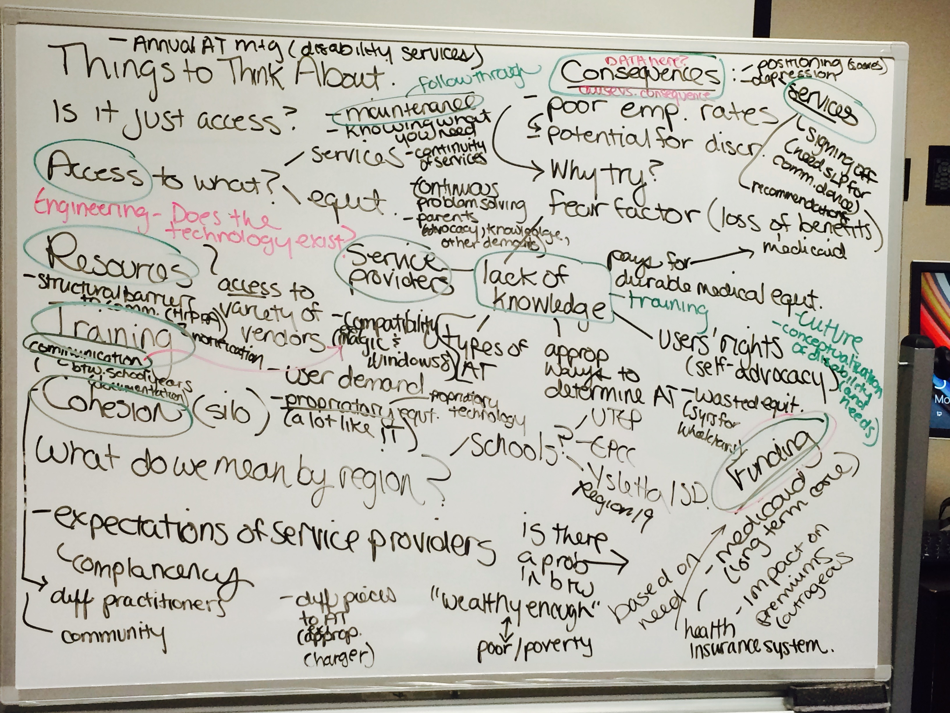
This conversation was facilitated using the Liberating Structure (see www.liberatingstructures.com ) 1-2-4-All (http://www.liberatingstructures.com/1-1-2-4-all/ ).
Note that “key terms” (see Q2) are circled in the above visual. The following is a written summary of this visual and also a glossary of key terms that arose from this conversation and the 1-2-4-All activity.
- The “AT Problem” may be more than just access.
- If it is an issue of “access,” than to what type of access are we referring? Services? Equipment?

Additional Comments (Not sure where to place in above figure): Expectations of Service Providers, Complacency, Community, Continuous Problem Solving, Parents (advocacy, knowledge, other demands)
Another question that arose during this conversation was, “What do we mean by ‘region’?”
- This has potential implications for our definition of target population.
- We talked about schools as one example: UTEP, EPCC, Ysleta ISD, Region 19
Additionally, Causes/Consequences of the “AT Access Issue” were discussed:
- Poor Employment Rates
  - Could be related to fear factor:
    - Why Try
    - Loss of Benefits
- Potential for Discrimination
The group discussed that Causes/Consequences may be one place to focus on for data.

The conversation that happened in response to Q3 resulted in the following visual:
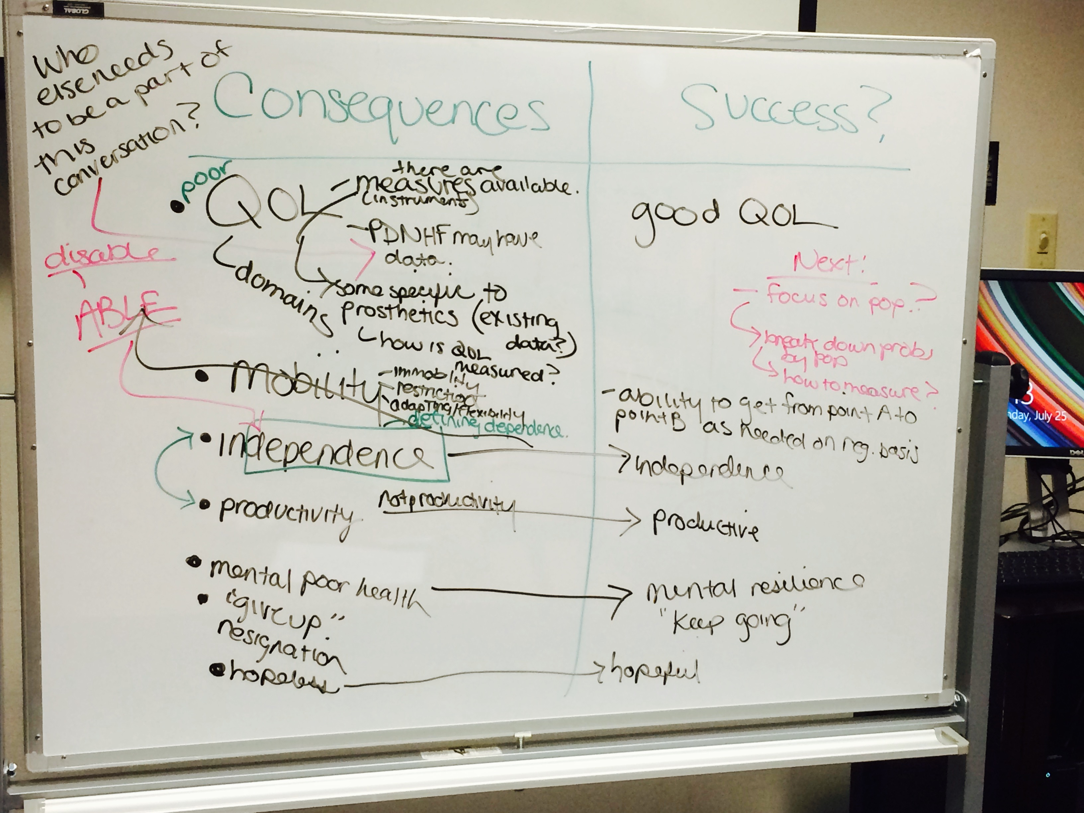
Moving forward, the team can expand on this table and brainstorm sources of data that might align with these constructs/variables.
The team ended the meeting with a closing circle and commonly expressed the sentiment that they are now left with a lot more questions and feel inspired to continue to work on the AT issue.

